# Portal Project Introduction

SADAD Portal Portlet project has two artifacts.

1. SadadPortlets (Portlet Project – Java WAR)
2. SadadServiceClient (Service Client Project – Java JAR)

SADAD Portlet project is developed for SADAD Internal users as well as for SADAD Partners (Banks and Biller). The project has mainly two categories of portlets, which are as follows.

1. EBPP Portlets
2. SADAD Admin Portlets

## EBPP Portlets

The EBPP Portlets gives SADAD Internal users and SADAD Partner users to query their uploaded data in SADAD system. EBPP Portlets have following five main segments, each of which contains one or two portlets for query purpose.

1. Account
   1. Query Account
   2. Rejected Account
2. Bill
   1. Query Bill
   2. Rejected Bill
3. Customer
   1. Query Customer
4. Payment
   1. Query Payment
   2. Rejected Payment
5. Refund
   1. Query Refund

## SADAD Admin Portlets

1. SADAD
   1. SADAD Admin
2. Banks
   1. Branch Code
   2. District Code
3. Billers
   1. Bill Category
   2. Payment Type
   3. Service Type
   4. Access Channel

# Project SVN Location

The project source code resides in SADAD SVN repository at the following locations.

* <http://teamforge.sadad.com/svn/repos/sadad2/Trunk/Portal/SadadPortlets>
* <http://teamforge.sadad.com/svn/repos/sadad2/Trunk/Portal/SadadServiceClient>

# Project Setup

## Setup Maven Portal Dependencies & Development Environment.

1. Copy WAS_pom.xml into a directory from where you can easily run mvn install command.
2. Rename WAS_pom.xml to pom.xml.
3. Open the Command Prompt in the same directory where you copy the pom file.
4. Type the following command.
   * mvn install –D*serverInstallationFolder={D:\IBM\Portal_80\WAS}*

*Change the highlighted value as per your Portal installation location.*

Repeat the above steps for Portal_pom.xml to install Portal dependencies in your maven repository.

Same can be achieved via RAD Run Maven Configuration.

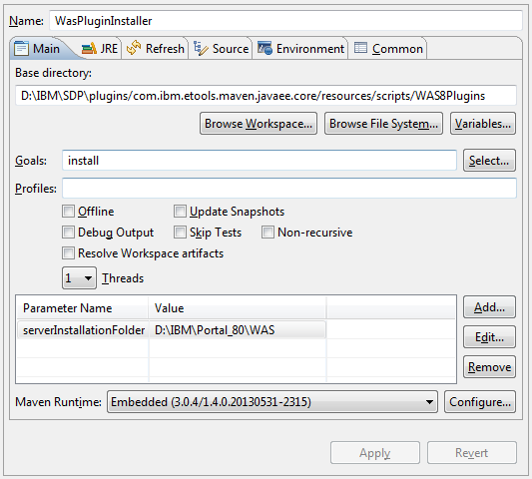 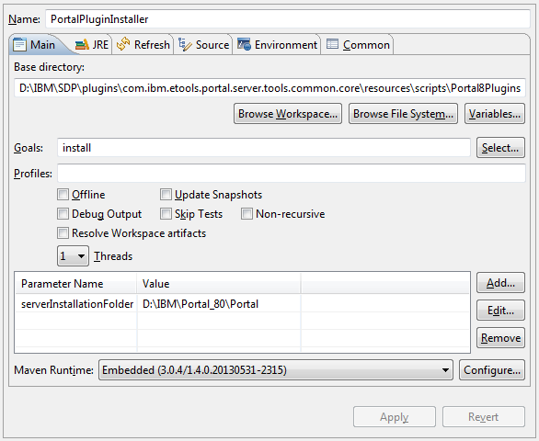

Project Parts and dependencies

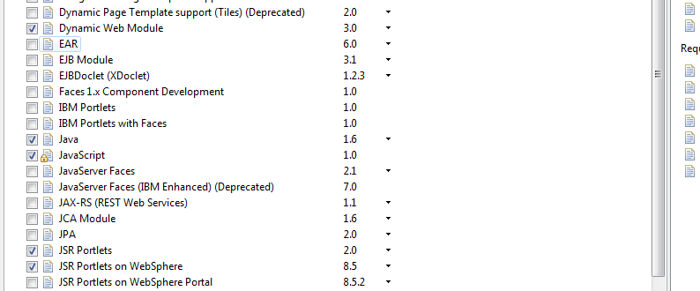

JSP Screen Organization

Naming convention for JSP files

Screen Display Technique

Rendering of JSP and JSON response

Java Development Pattern

Explanation of SadadSessionBean, CoreEbppSessionBean and others

JS and CSS files

Resource files for language bundles

Naming conventions for request parameters